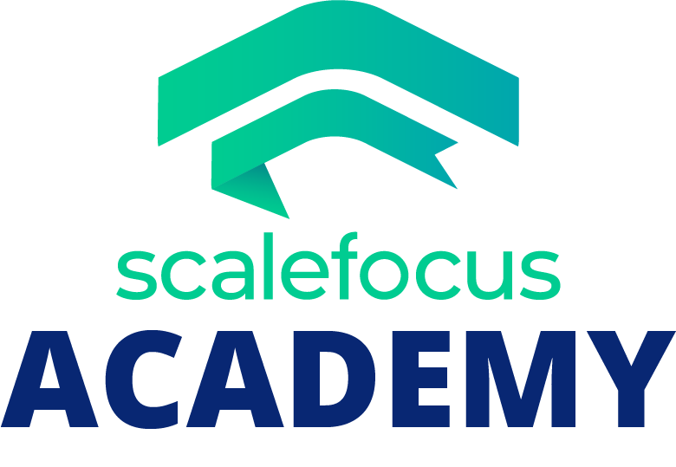Contents

1. Topic 1

2. Summary 1

2.1. Milestones 1

2.2. Level of complexity 1

2.3. The realization itself 2

2.4. Conclusion 2

# Topic

The topic of the project is a management application which manages an IT company’s operation and displays multiple teams working on multiple projects.

# Summary

The project management system works only with registered users, represented by an administrator permissions (optional), username, first name, last name, and last but not least, by a password.

## Milestones

The first milestone was actually sitting and deciding what to do. After that I set eyes on planning the project, and more precisely, what it is going involve. Then I got to the difficult part – coding. I have faced a lot of painful tasks along the way, including bug fixes. After that, I started doing the presentation and documentation.

## Level of complexity

In my opinion, the level of complexity was hard. The most difficult and time-consuming part was figuring out how to start. I think that this project was probably harder than every single project we have ever done in school. The time which we had was little, which bothered us a lot.

## The realization itself

For the realization, I have used various technologies, as well as Visual Studio 2019 for coding, Microsoft Word for writing the documentation and PowerPoint for making the presentation, and GitHub for storing all that stuff. Using these products in depth, showed me how easy you can manage your projects.

## Conclusion

In conclusion, the project really helped me reconsider many things. The 3 most important things I have learnt throughout the whole experience are:

* I should have studied more to be easier for me now making the project.
* I should have been more productive and work for time.
* Programming is not that easy!